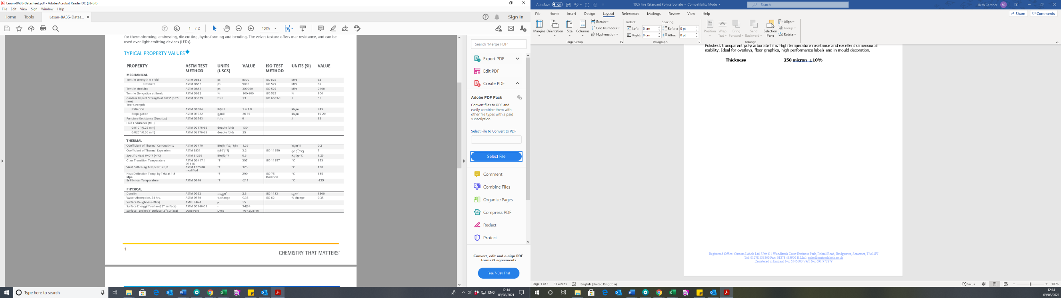

**Face:**

Polished, transparent polycarbonate film. High temperature resistance and excellent dimensional stability. Ideal for overlays, floor graphics, high performance labels and in mould decoration.

**Thickness: 250 micron ±5%**

# GLOSS POLYCARBONATE 250mic

